**Hospital Database hospital.db**

**Getting the patients table[1]**

**mysql> select * from patients;**

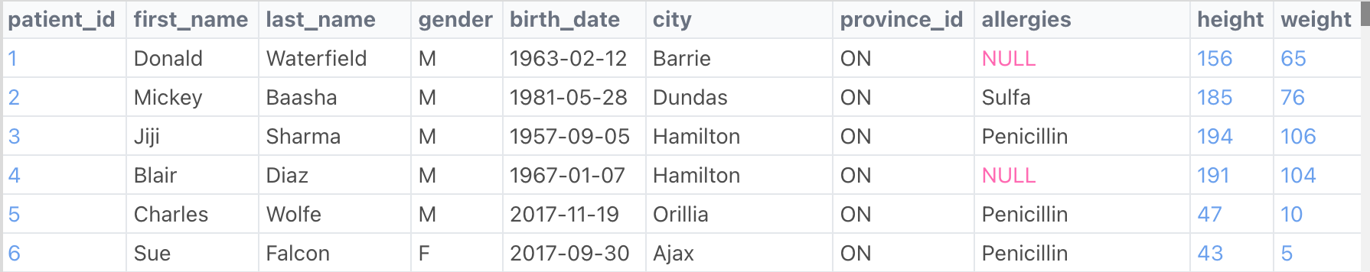

**1. Show the first and last names of patients who do not have allergies. (null)**

**mysql> select first_name, last_name, allergies**

**from patients**

**where allergies IS NULL;**



**2. Display all the names that start with the letter C**

**mysql> select first_name**

**from patients**

**where first_name like ‘C%’;**



**3. Show the first name and last name of patients that weigh within the range of 100 to 120 (inclusive)**

**mysql> select first_name, last_name, weight**

**from patients**

**where weight<=100 and weight>=100;**

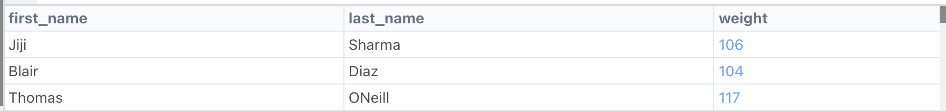

**Getting the admissions table[2]**

**mysql> select * from admissions;**

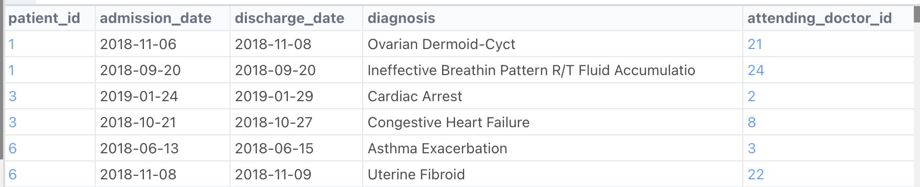

**4. Show patient_id, first_name, and last_name from patients diagnosed with ‘Cardiac Arrest’.**

**mysql> select patients.patients_id, first_name, last_name**

**from patients**

**join admissions on admissions.patient_id = patients. patients_id**

**where diagnosis= ‘Cardiac Arrest’;**



**Getting the province_names table[3]**

**mysql> select * from province_names;**

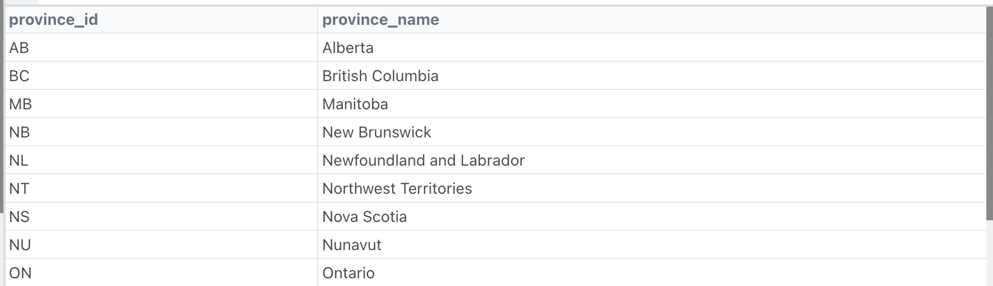

**5. Show each patient's first name, last name, and full province name of each patient.**

**mysql> select first_name, last_name, province_name**

**from patients**

**join province_name on province_name.province_id = patients.province_id;**

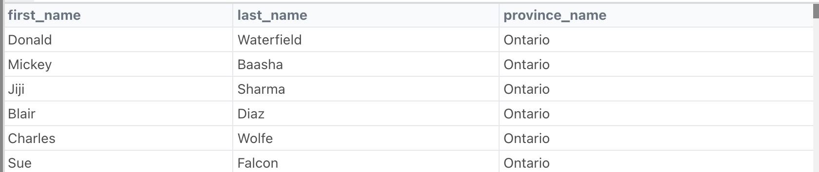

**6.Natural Join to join the table ‘patients’ and ‘admissions’ using the common field ‘patient_id’:** (shows only the records with common patient_id in both the tables)

**mysql> select \***

**from patients**

**Natural Join admissions;**

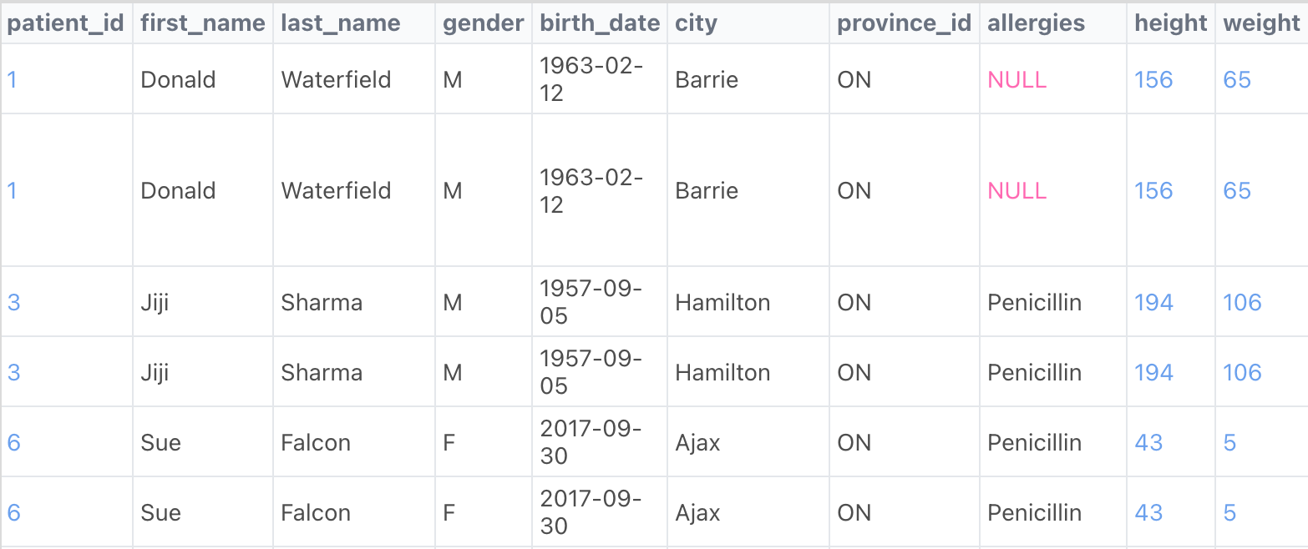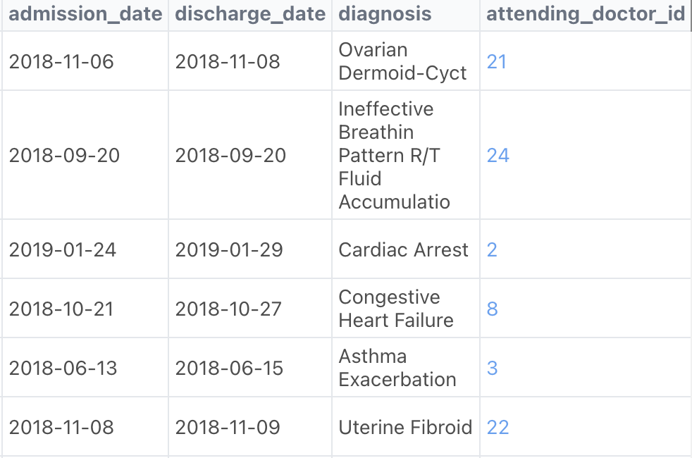

**7. Left Join to join the table ‘patients’ and ‘province_names’ using the fields ‘patient-id’ in ‘patients’ and ‘province_id’ in ‘province_names’:**

(shows all the records of the left table joined with values of the right table and wherever the values are not present in the right table, it shows ‘null’)

**mysql> select \***

**from patients**

**LEFT OUTER JOIN province_names on patients.patient_id = province_names.province_id;**

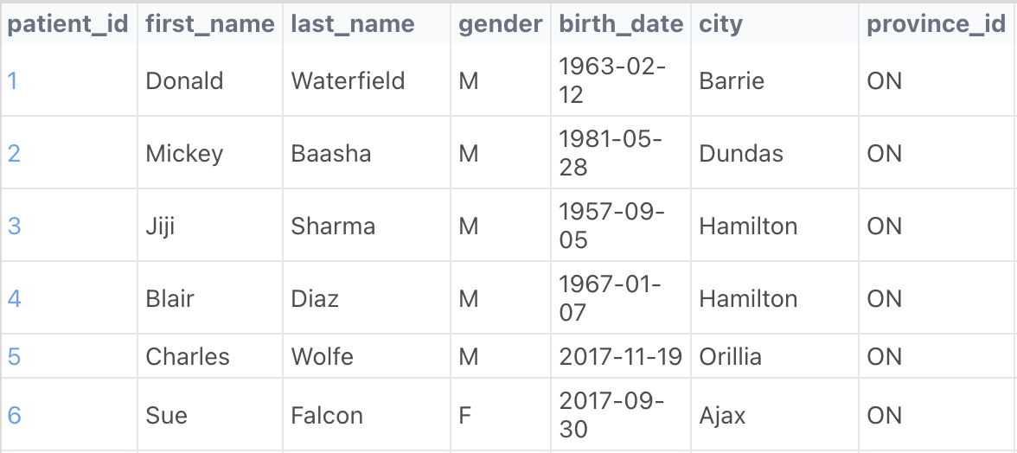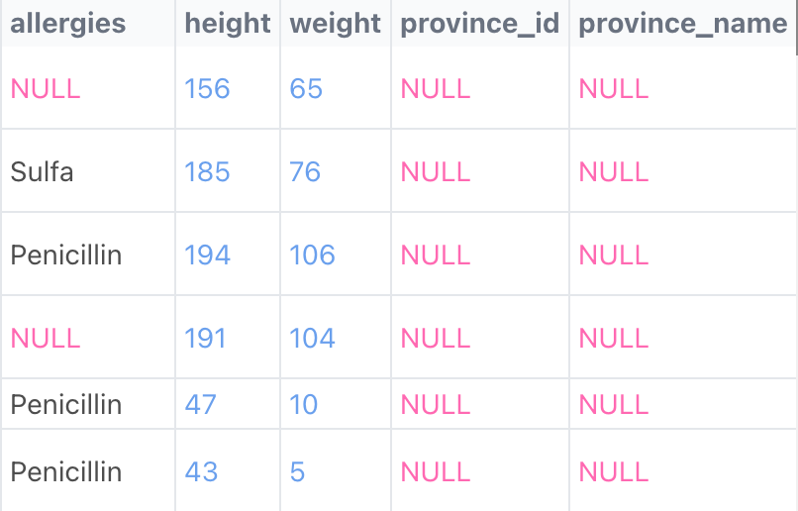

**8. Show unique birth years from patients and order them by ascending.**

**mysql> select DISTINCT YEAR(birth_date) AS birth_year**

**from patients**

**Order By birth_year;**

| **birth_year** |
| --- |
| **1957** |
| **1963** |
| **1967** |
| **1981** |
| **2017** |

**9. Show the total amount of male patients and the total amount of female patients in the patients table.**

**Display the two results in the same row.**

**mysql> SELECT**

**(SELECT count(*) FROM patients WHERE gender='M') AS male_count,**

**(SELECT count(*) FROM patients WHERE gender='F') AS female_count;**

| **Male** | **Female** |
| --- | --- |
| **5** | **1** |

**Getting the doctors table[4]**

**mysql> select * from doctors;**

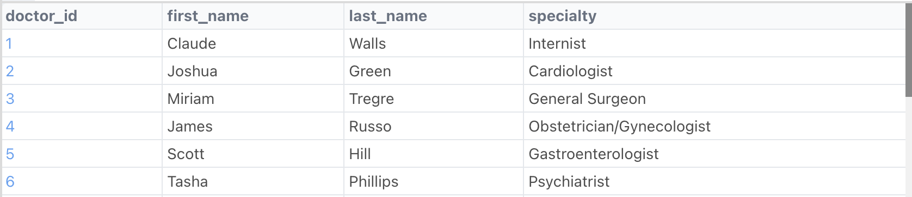

**10. For each doctor, display their id, full name, and the first and last admission date they attended.**

**mysql> SELECT CONCAT(patients.first_name, ' ', patients.last_name) as patient_name, diagnosis,**

**CONCAT(doctors.first_name,' ',doctors.last_name) as doctor_name**

**FROM patients**

**JOIN admissions ON admissions.patient_id = patients.patient_id**

**JOIN doctors ON doctors.doctor_id = admissions.attending_doctor_id;**

